


UNIVERSITY OF THE PHILIPPINES CEBU
College of Science
Department of Computer Science

TIP: Tracker for Inventory and Profit

A Project Report

In Partial Fulfillment of the Course Requirements
for CMSC 21 – Fundamentals of Programming

Submitted by:

Jason John S. Bisuela
Benedict John D. Dela Cruz
Isabela Cristie B. Ollaban
Kyle Dominic D. Olmedo

Submitted to:

Nasvin F. Del Rosario
Department of Computer Science

Introduction

In today’s business climate, efficient profit and loss management and inventory management are crucial for the sustainability of a business especially those who have small retail establishments like minimarts and sari-sari stores. From the study “Accounting Practices of Sari-Sari Stores in Brgy. Makiling, Calamba, Laguna: Basis for Community Extension Program of the College of Business and Accountancy“, published in October 2018, the majority of the respondents favored manual methods to bookkeep over computerized ones. The high preference towards the manual accounting is attributed to its perceived lower cost and convenience with the manual methods, especially for the businesses with minimal transactions (Alusen & Javier, 2018).

However, relying on manual calculations for revenue and profit assessments is prone to errors and consumes a lot of time. Since it is time consuming, some of the business owners rarely calculate the profits of their products which could lead to an unawareness of which products sell well and which products don’t. Some business owners track the inventory of their products through mental footnotes and paper which could be susceptible to error and could lead to a situation where the product is unavailable when it is in demand, among other problems that arise with poor product tracking. These circumstances could lead SME owners to make poor decisions for their business.

Problem Statement

Some small business owners could have difficulty tracking the inventory of their products since they could use more sophisticated methods which could be prone to error such as writing it in paper or mental footnotes. They also could have a difficulty in checking if their products are making a profit since they may use calculations or in some cases, they won’t check for profits and feel if they’re making a profit. There is a need for a user-friendly system that could track inventory of items and check for the total revenue, cost, and profit gained from the products to check if the store is making profit or bleeding money. Furthermore, a profit tracking system could lessen the mental load of calculating individual and total expected profits as the system would do it for them.

Solution

Project TIP is a program that aims to make bookkeeping software friendly to sole proprietors that want to start a business with a sari-sari store. Through this, sole proprietors are able to keep track of the sari-sari store’s finances, in order to make sound decisions for their business.

Description
With the aid of the accounting cycle, TIP aims to aid the sole proprietor with the entire accounting cycle. The main goal of this project is to help simplify the calculation process for the sole proprietor, with the net profit/loss of the sari-sari store and to help track the inventory of the products currently being sold in the sari-sari store. The calculations of profit/loss can be done erroneously, especially if not done properly, hence this program, alongside its goals to store and track inventory, help keep the numerical data reflective of the store’s current financial position. As for the inventory, a periodic inventory system was observed for uniformity.

Initialization
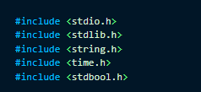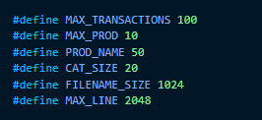

The research team utilized the following preprocessor directives for the project. The following #include preprocessor directives was used for the program since there was a need for convenient naming for the inventory management and obtaining of the system time when the transaction was recorded. The following #define preprocessor directives are used for the size of struct arrays and the maximum size of product and category names.

Inventory Management

The code for the product details was derived from the concepts of struct, wherein key variables that help describe the product and its current inventory would be used to separate one product from another. The team utilized the following structures to be used for the inventory of products. The product utilizes the struct Product_Details to contain the product’s name, weight, price, quantity and costs.
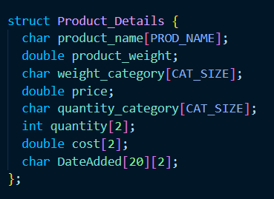

The team accounted for the category of products in the sari-sari store using the struct Categories to separate the products from one another. Each Category contains an array with a size of defined variable MAX_PROD or 10.
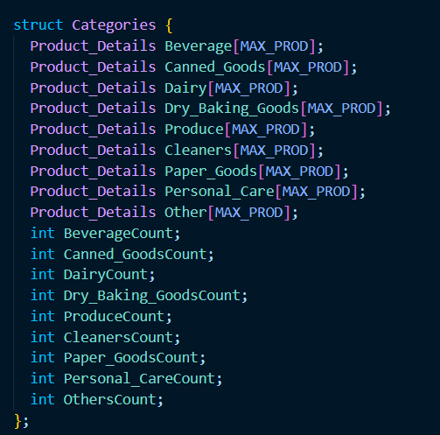
The integers BeverageCount to OthersCount function as a limit to ensure that for-loop functions that check the array won’t go beyond the index where data is available and to read multiple products in each category.

The main program utilizes the function main_interface() for the user to selectively pick which function of the program that they would want to use and it utilizes aesthetic functions such as TitleScreen(), header() and greeter() so that the program has aesthetic qualities.
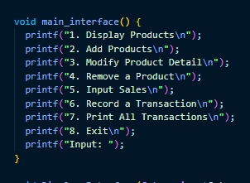
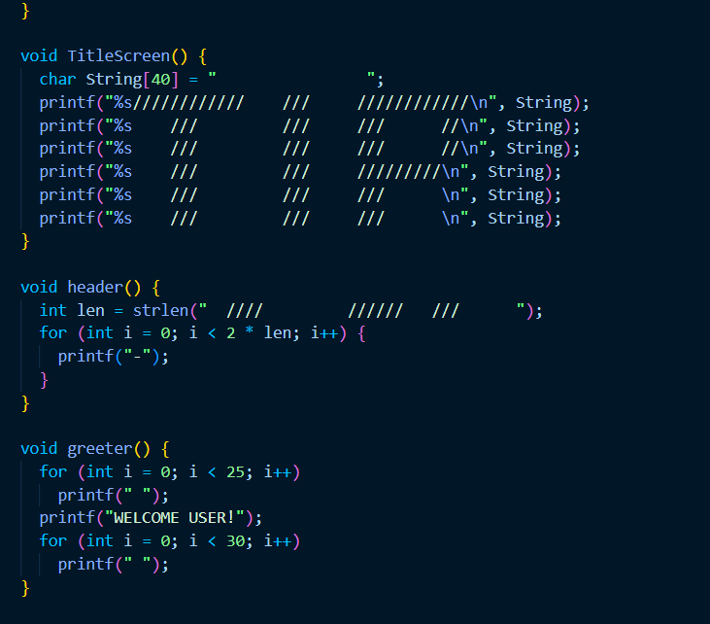

The inventory side of the program utilizes a text file named “product.txt” to check on the items that were initialized or inputted by the user. It has the format of:
Category | Product_Name | Price | Weight_Category | Weight_of_Product | Quantity_Category | Quantity of object

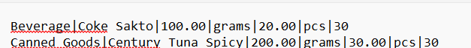

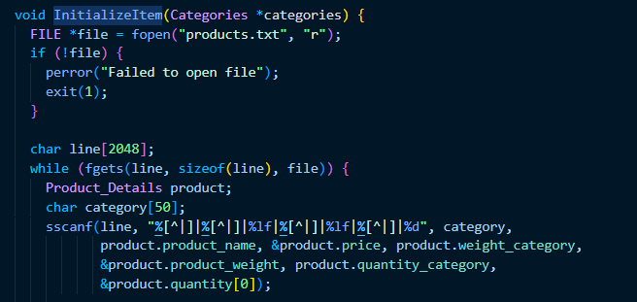
Afterwards, the function InitializeItem() reads from the file and checks for the products in the file and assigns them into the console. The function splits the line into multiple data using sscanf and the first data Category is used to determine if the item in the text file belongs to a certain category. If the item in the text file belongs to a certain category, the category count from the struct Categories will be used as an index so that the item and its product details will be assigned as a part of that category’s products.
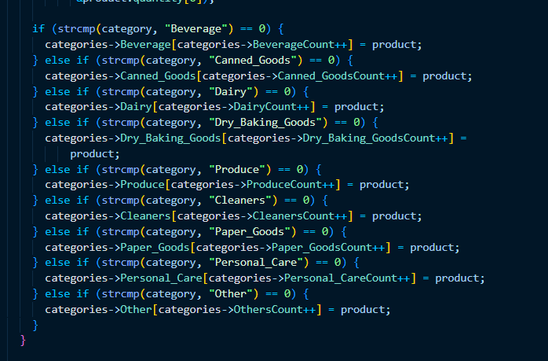

After the product is initialized, there are four functions in the program that will use the inventory: Display Products, Add Products, Remove Products, and Modify Product Details. These functions will use struct Categories. In the main function, the research team initialized an instance of the struct Categories Item_Store and a struct pointer ItemP, ItemP was then assigned to the address of Item_Store. The four inventory functions use ItemP or a struct pointer of Categories as a pointer.

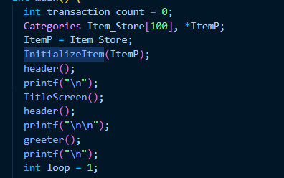

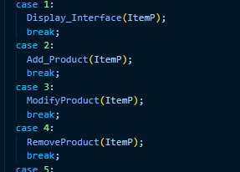

For the display function, it utilizes for-loops and the struct pointer of Categories. The Display function consists of the DisplayInterface(), the multiple display functions involving the different categories, and the DisplayAll() function which outputs every item inside the inventory. The Display Interface follows a similar format from the main interface except the choices involve displaying the categories and the option of displaying all items.
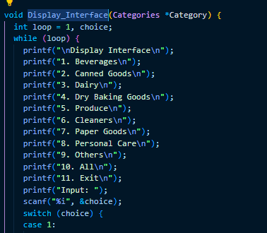

The DisplayInterface() is inside a loop to ensure that if the user wants to display another category, they don’t need to input back from the starting menu. The different display functions are inside the switch cases.
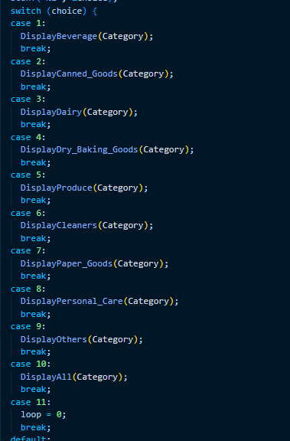
The Display Category functions are similar to one another in that they use the same process in outputting everything inside the category array. They utilize the category count to function as a limit for the loops to not go far when displaying the product and its details.
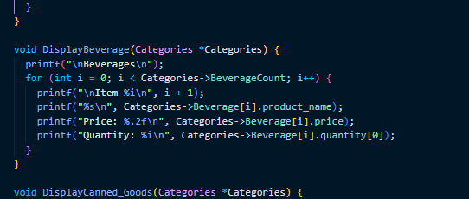
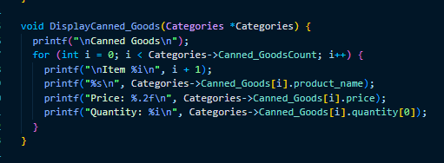
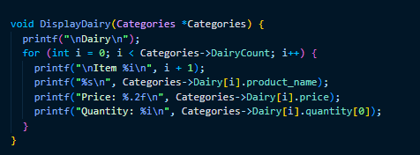
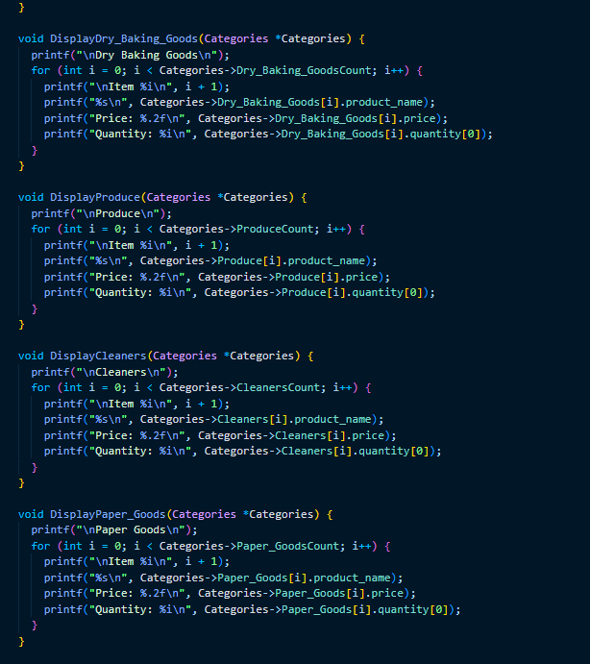
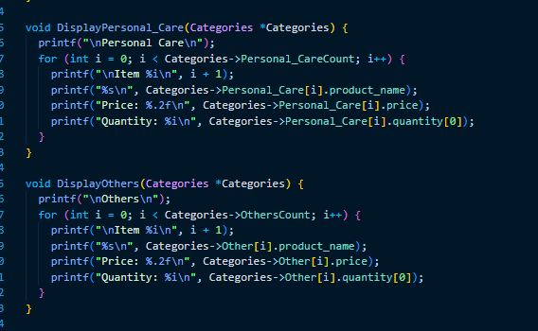

The DisplayAll() function basically outputs all of the other display functions in a certain order.
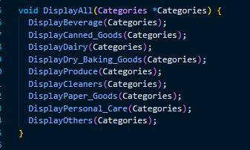

Like the display function, the Add products function uses the struct pointer for Categories and has an interface inquiring the user about the category of the product that the user would want to add.

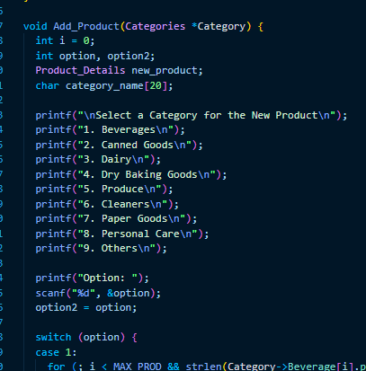
The switch cases are used to check the index where the category array is empty so that it will be where the new product is added.
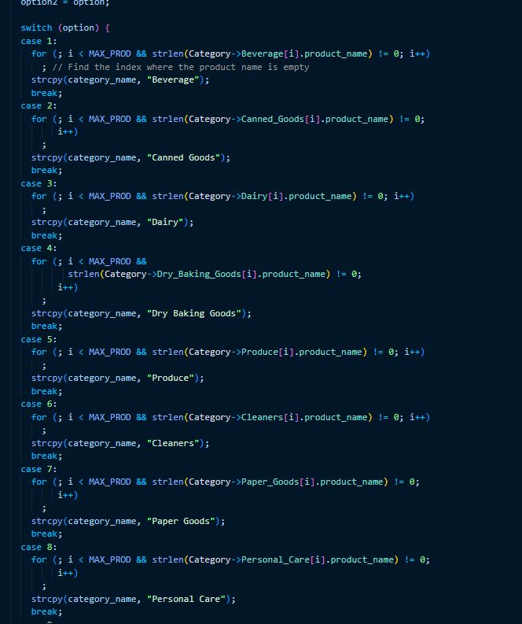
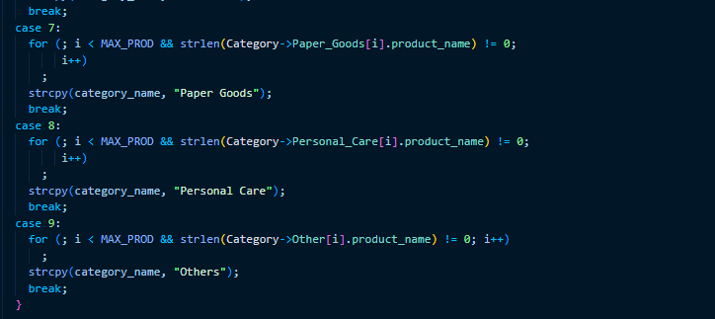

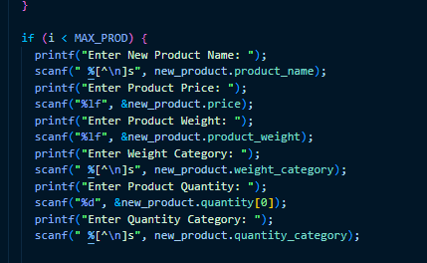
The program asks for details about the product such as its name, price, weight, weight category, quantity available, and quantity category. After the user inputs the details, the details will then be saved to the product.txt file through the use of file handling and appending the new product’s data.
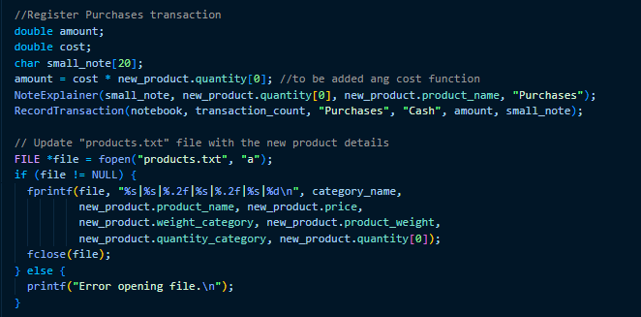
After the details are saved onto the file, the Product Detail struct new_product’s details are then assigned to the Category of the product at the index where the product name is empty.

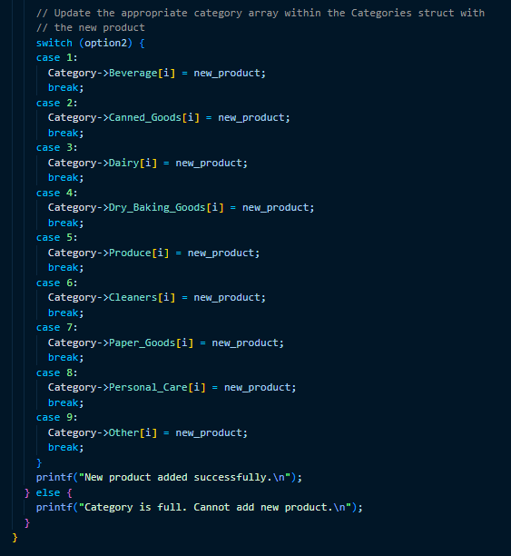
The Modify function uses the same parameters and interface from the Add Product function. After the user selects the category of the product they want to modify, they must input the name of their product so that it will be searched through the array of the category.
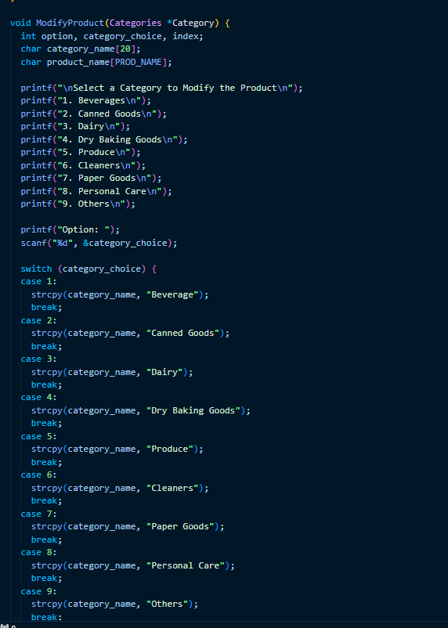

If the Modify function locates the product at the certain category, it will move on to the next interface which asks the user what detail they want to change.
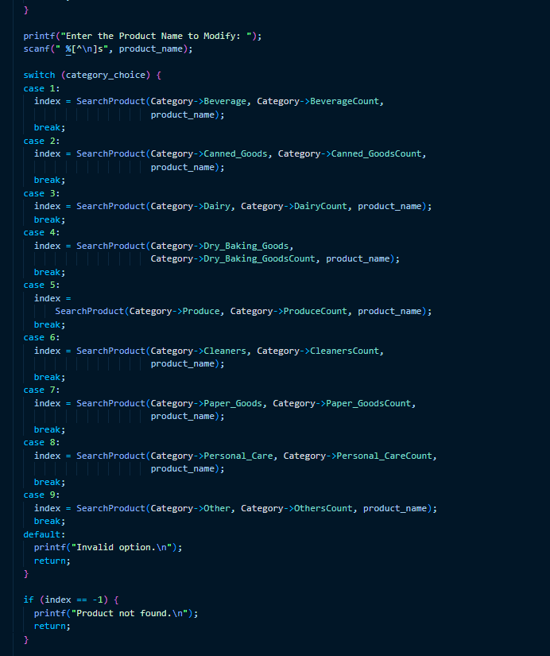

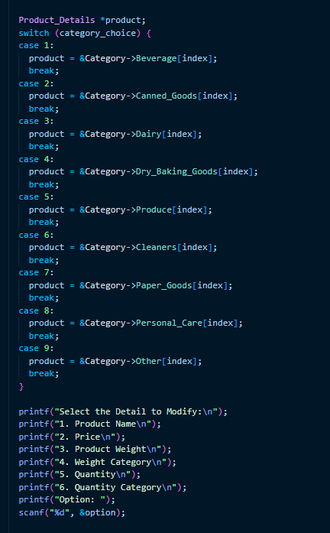
The program asks the user what product detail they want to change. After the user inputs their desired product detail to be changed, the product detail changes will be updated in the product.txt where the line containing the product name will be rewritten so that the product changes could be saved outside of the console. It utilizes file handling so that the code could be rewritten, the product’s details including the updated details are updated in the text file.

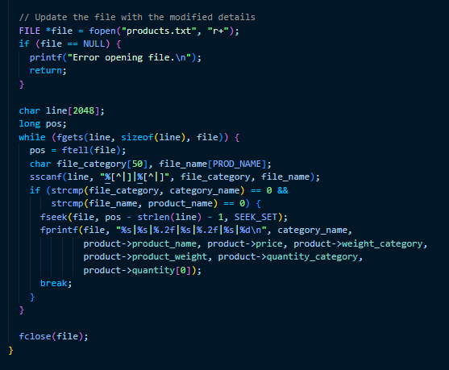

The Remove Product function is similar to the Modifier functions where they first inquire about the category of the product they seek to delete.
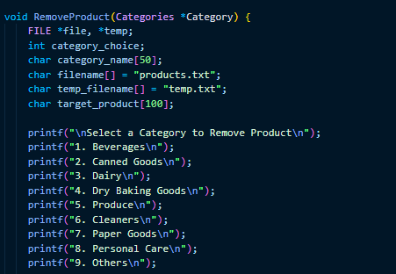
After the user selects the category of the product, they are asked to input the name of the product they are going to delete.
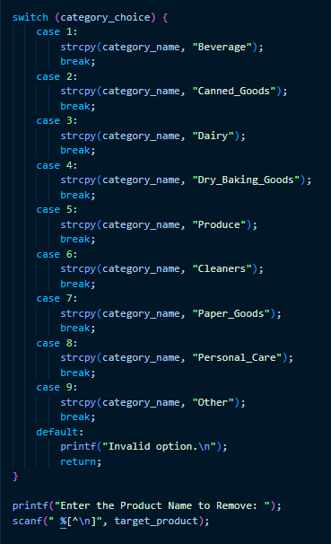
After the product name was inputted, the program updates the product.txt file to not include the product.
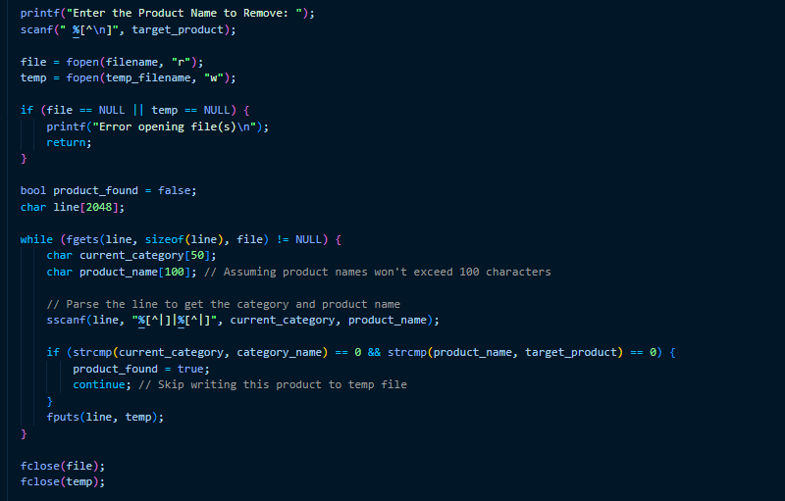
The program creates a duplicate of the product.txt file known as temp.txt where temp.txt copies everything from product.txt except for the specific product that was removed. Temp.txt’s data is then assigned to product.txt, updating the program to not include the product to be removed.
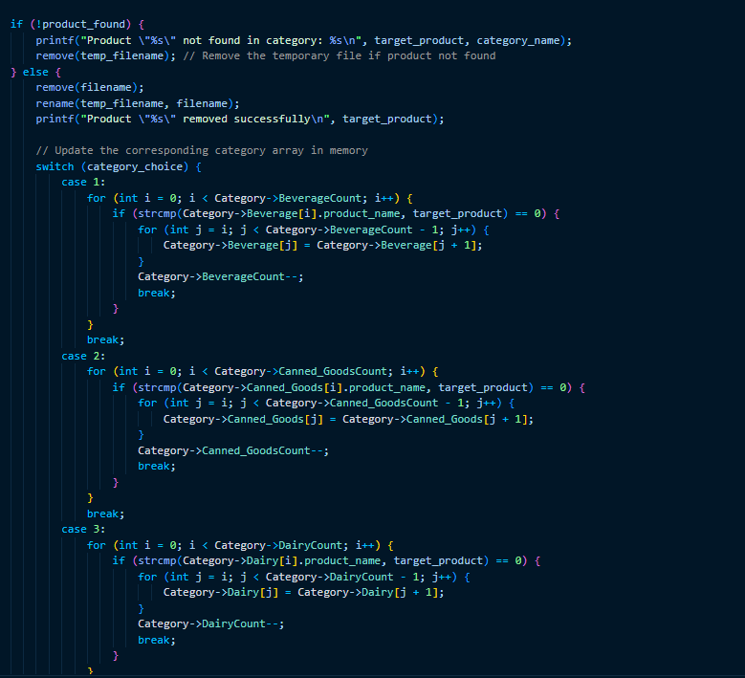

If the product is not found, then the program will output the message: “Product %s not found in category: %s” where %s is product_name and category respectively. If the product was successfully removed from product.txt, the current array where it was previously used is updated to not include the product.
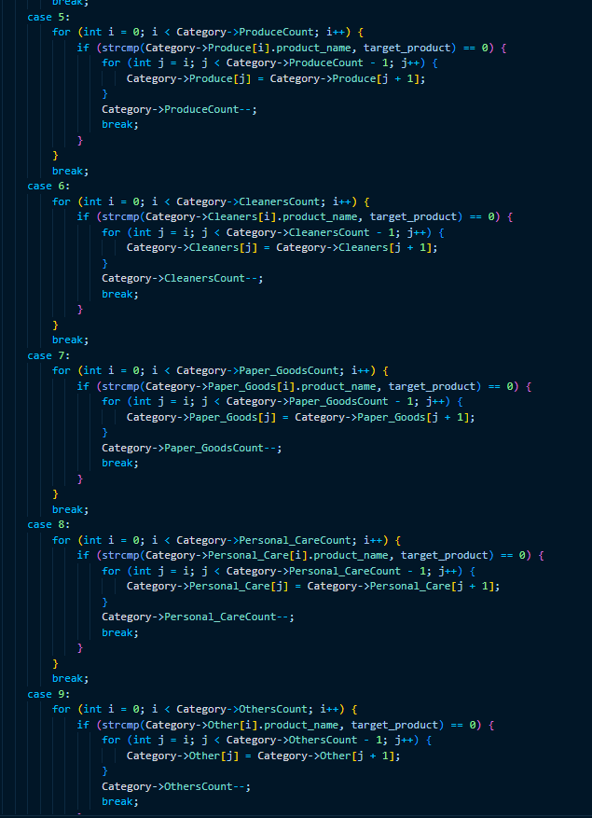
There were other functions that were used aside from the four major functions. There was the search function that searches for the product in a given category and returns the index where the product was located.

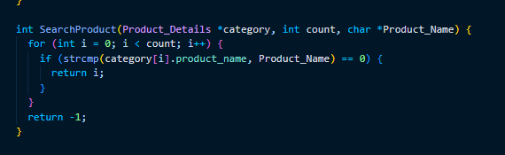

All of the functions utilize the same parameters and the same file to ensure uniformity in the code.

Transactions and Accounting Cycle

The structure used for the journal entries accounting the transactions on the store is the JournalEntry which contains data for the date, the credit, the debit and the note which elaborates on the economic activities occurring within the store.
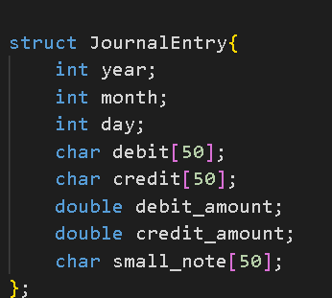

The following functions in the main interface utilize the transaction:
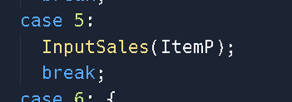
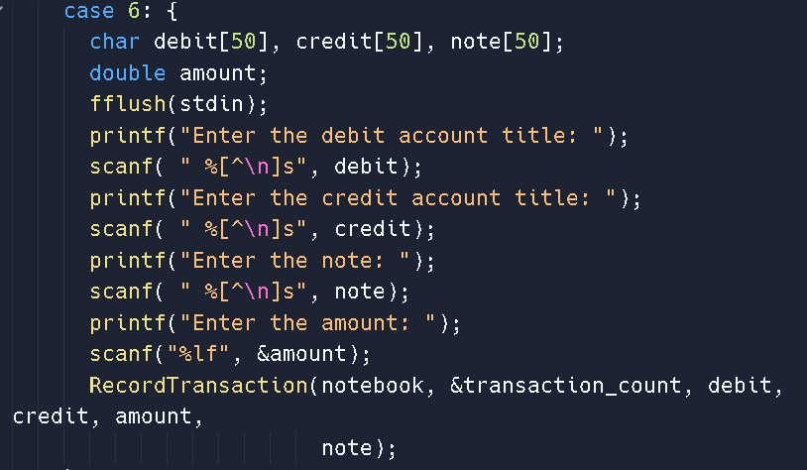
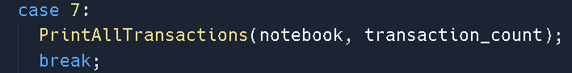

The Input Sales function inputs the quantity sold by users and follows the same interface as the Addition function, the Remover function and the Modifier function.
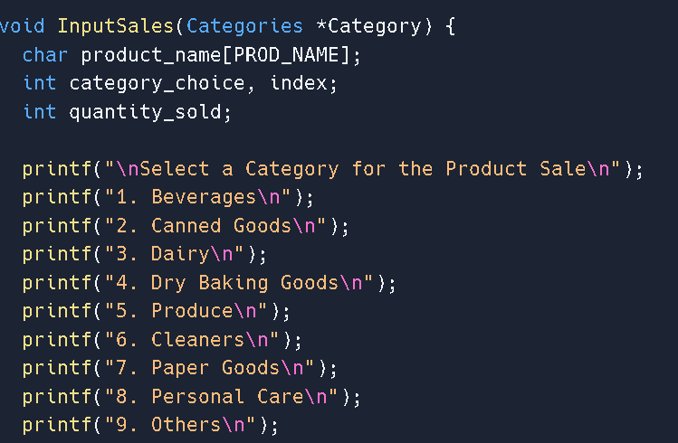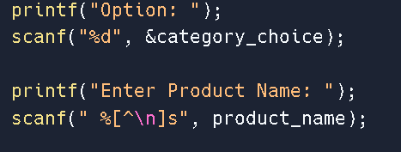
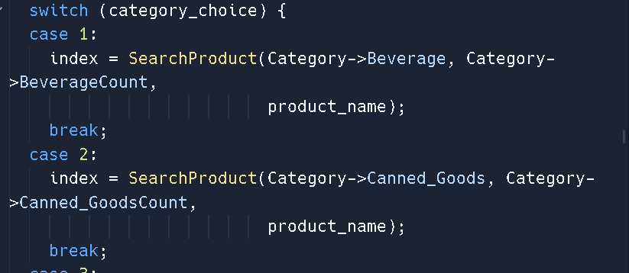
The program asks for input from the user and similar to the Modify function, it uses switch cases and loops to check for the category where the product could be located. After the product is located, the program asks for the product’s sold quantity.
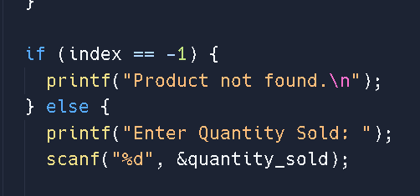
The quantity sold will then deduct the quantity available from the product.
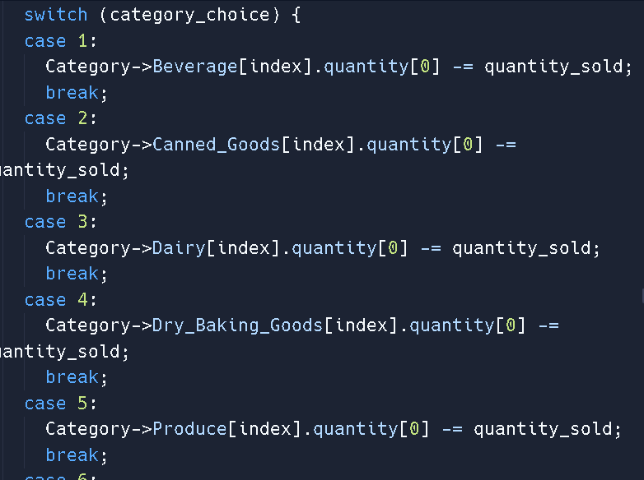
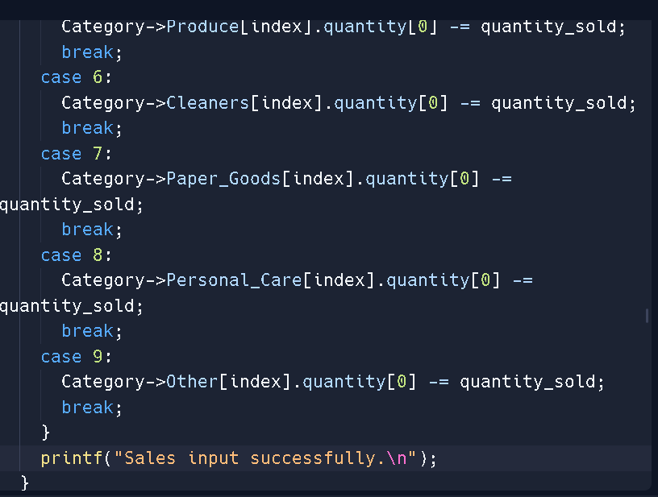
The accounting cycle program utilizes the following structures to store values relating to transaction:

Use of Structure and Malloc
The code for the journal and cost recording will mainly be derived from the concepts of struct, wherein key variables that help describe the product and its current inventory would be used to separate one product from another.

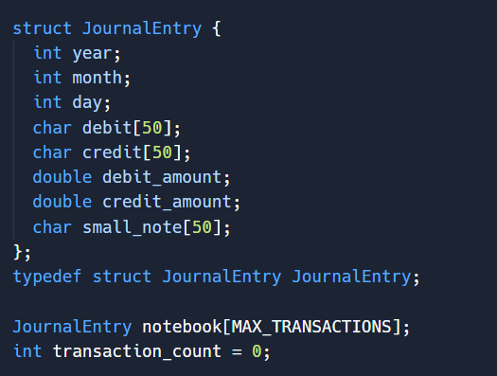

Note Explainer
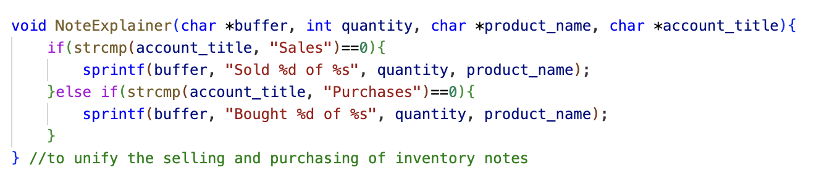
This function helps the program generate short descriptions per modification of the inventory system. Like most transactions in a general journal, this program describes each transaction with the product name and the quantity bought/sold.

Record Transaction
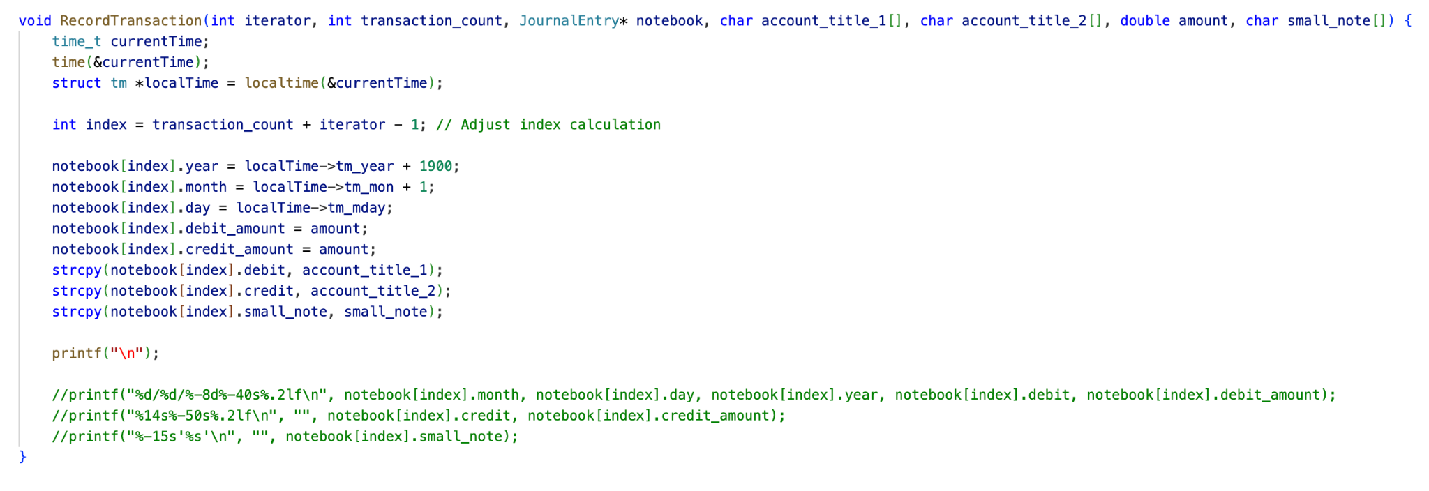
This function allows for the recording of transactions that take place within the business with external entities. In recording purchases and sales on account, adjusting necessary entries to reflect real-time transactions, and the like, the transactions serve as basis when used to reference transactions over time. This helps keep track of transactions that take place.

Printing of the General Journal
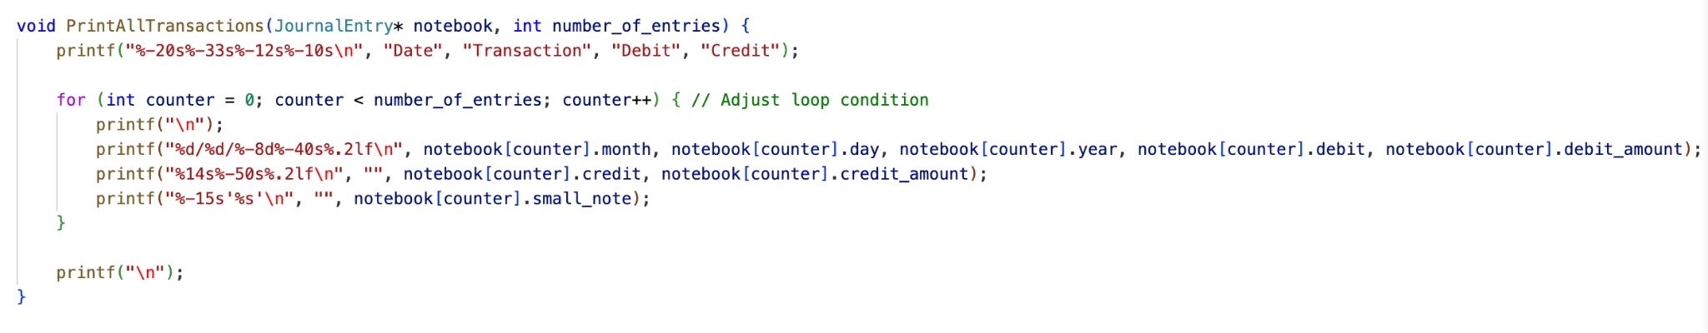
This function mainly prints all of the transactions that took place within the business’s duration of operation. From start to finish, all transactions that were recorded in the program will be printed with this function.

General Ledger Function
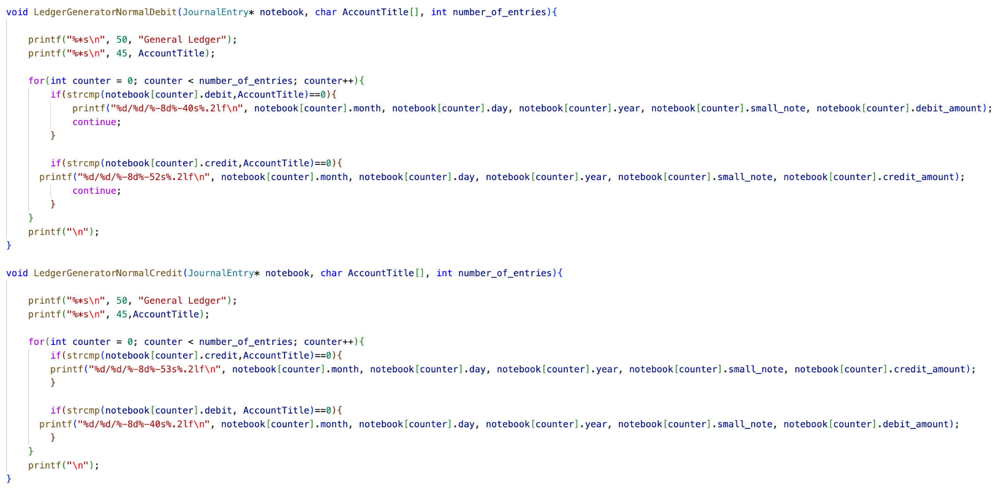
The General Ledger is being treated as a function that prints only the specified account titles; the program filters the transactions to display the transactions with the relevant account titles. There are 2 functions to help describe the normal accounts per account.

Income Statement, SCE, SFP, SCF Generation Function
Should the sole proprietor want to find details as to how the profit/loss was earned, the program will generate a summary of all the variables, affected or not, in presenting numerical descriptions of the business during the current period.

The financial statements are divided into 4 functions:
> IncomeStatement
>StatementofChangesinEquity
>StatementofCashFlows
>BalanceSheet
The functions call the other functions in the program in order to perform the calculations needed to present the financial statements.
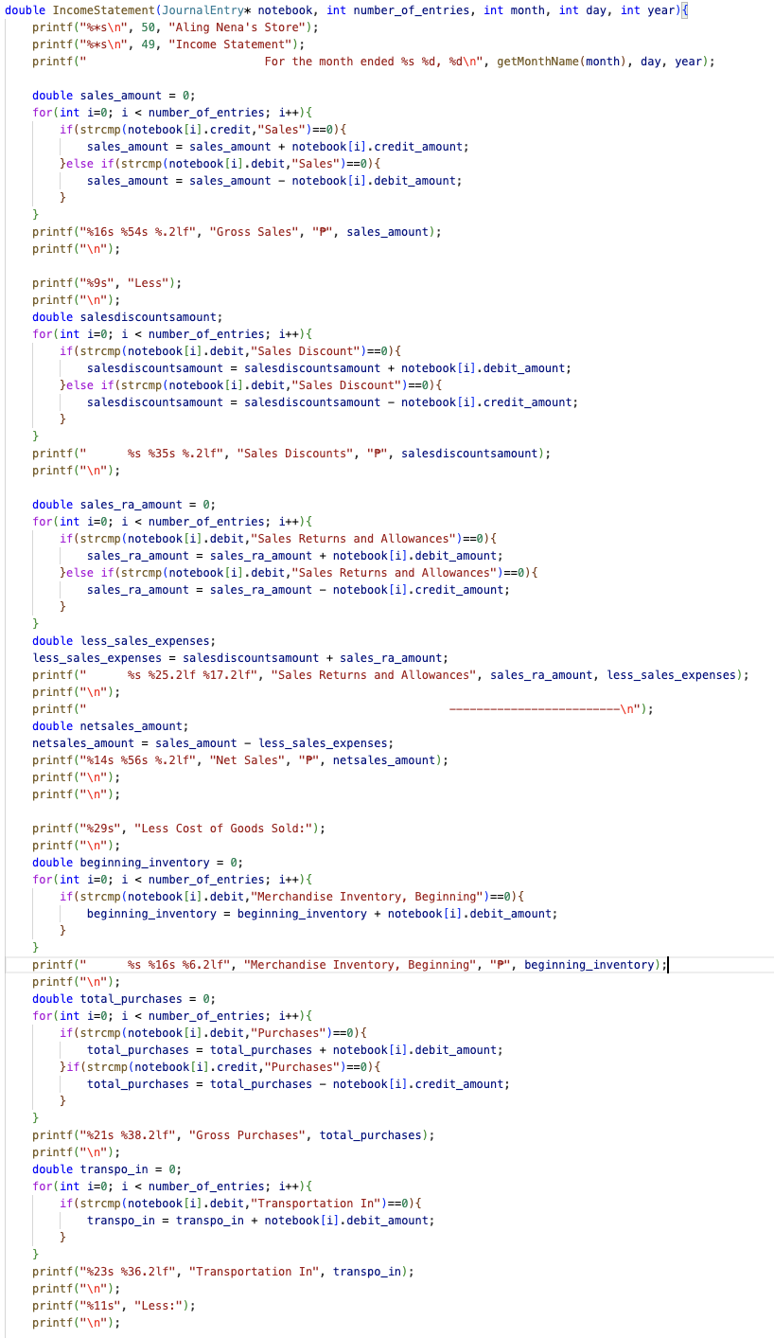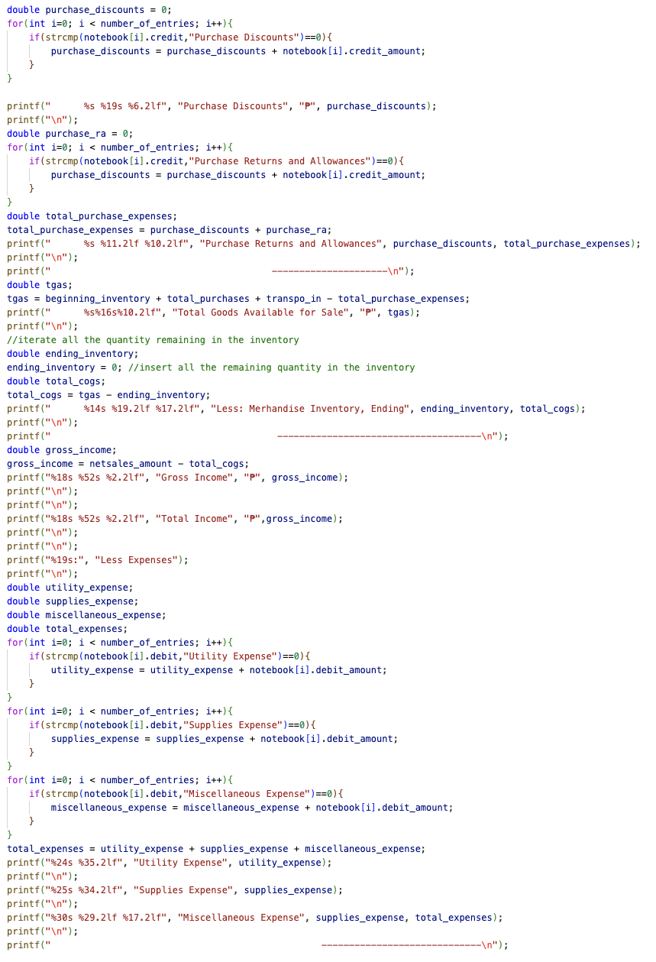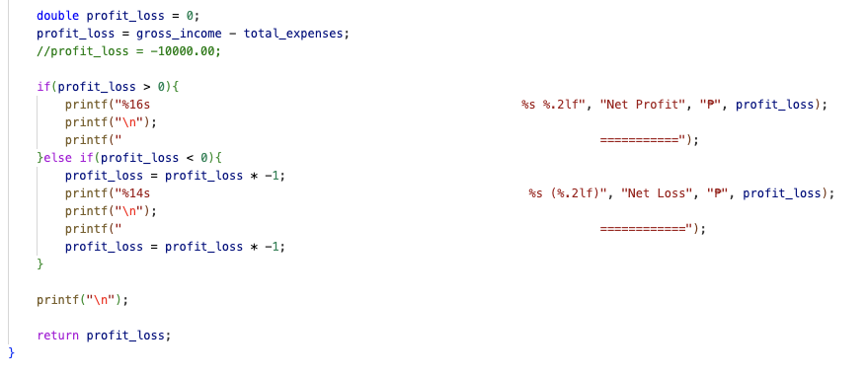
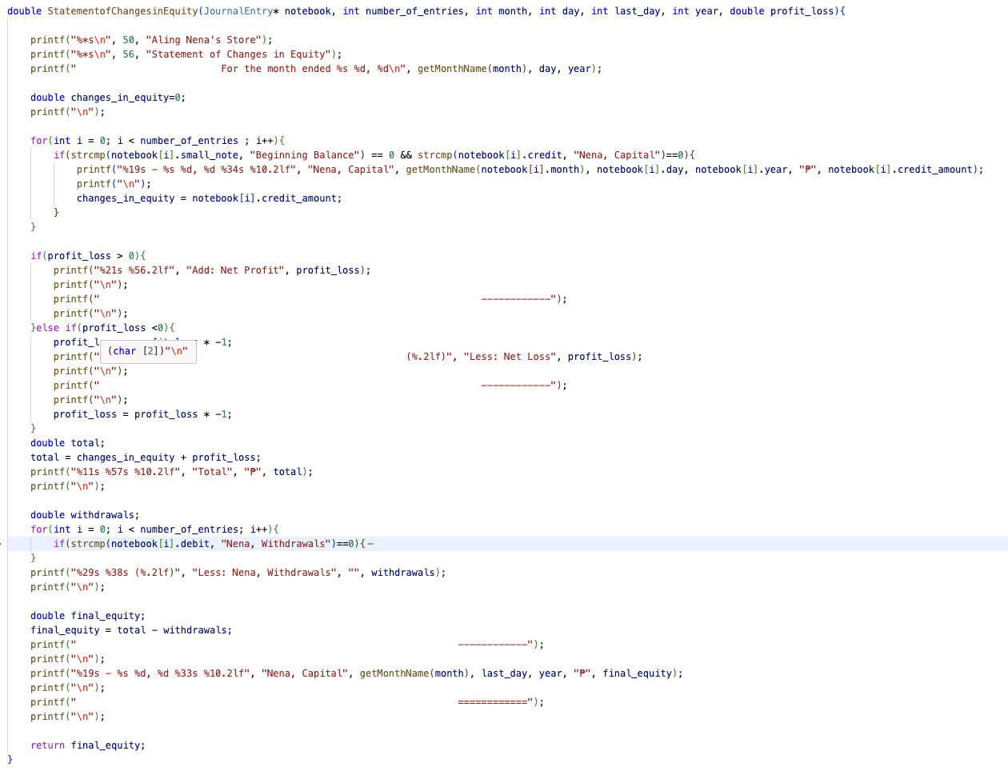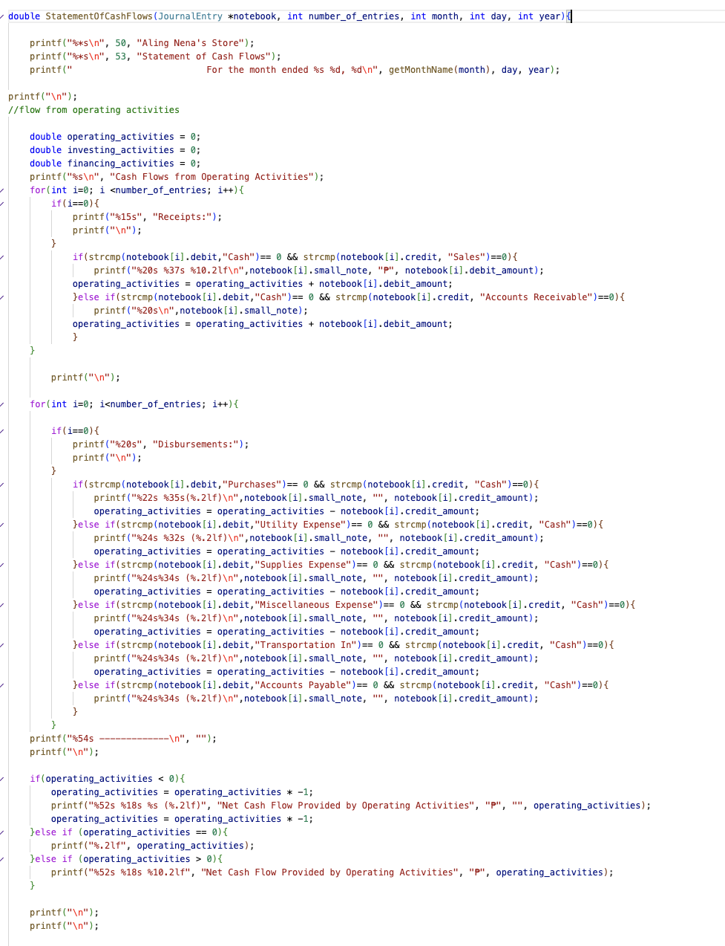
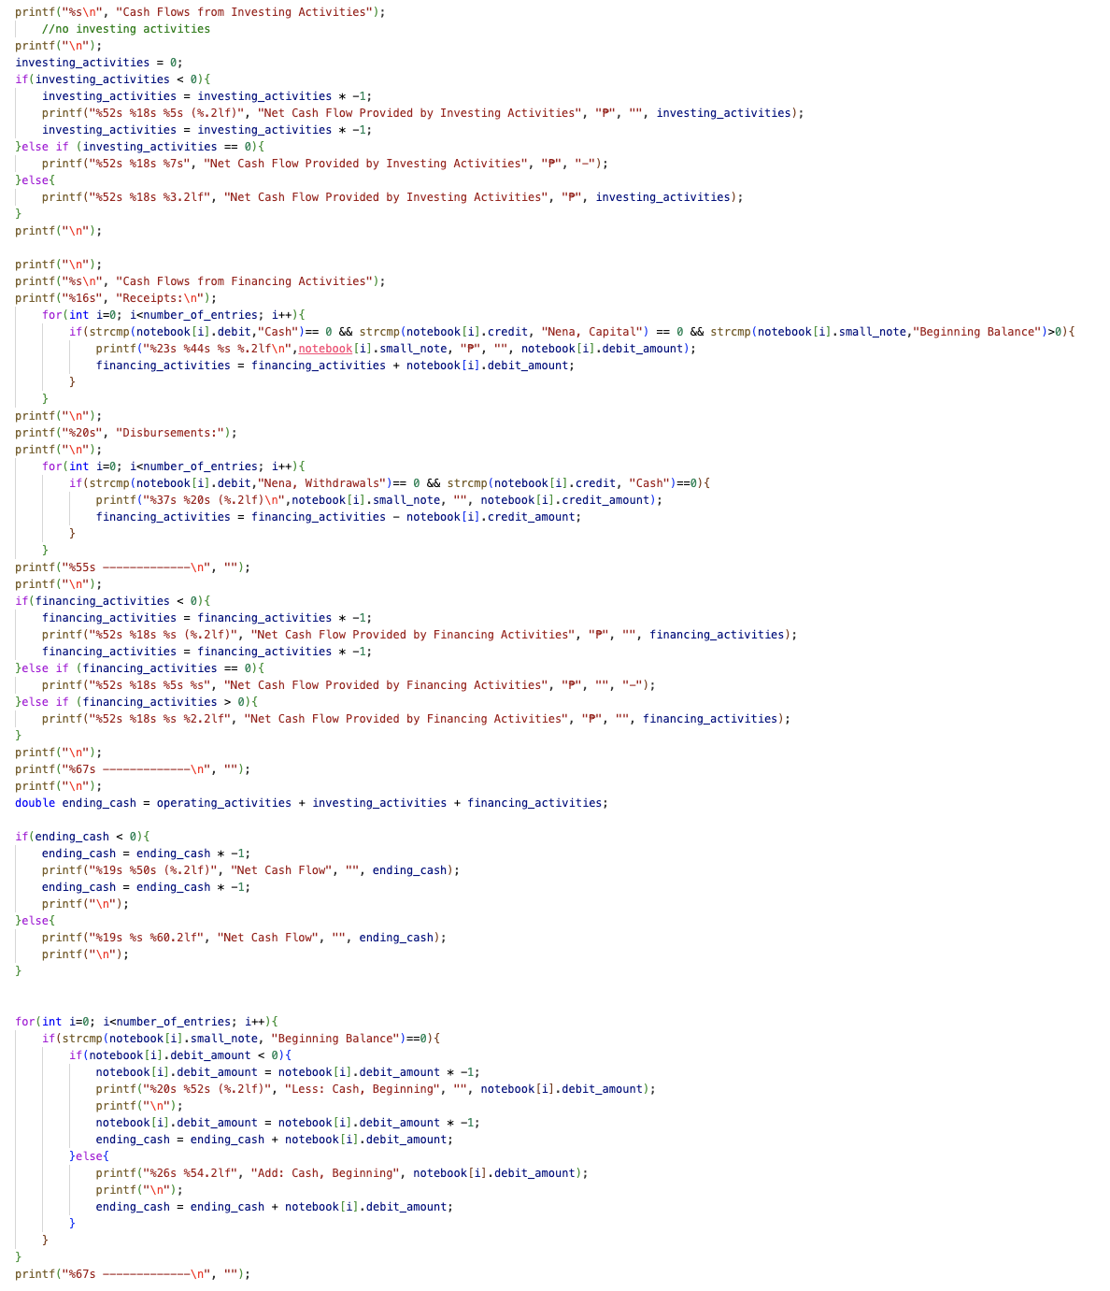
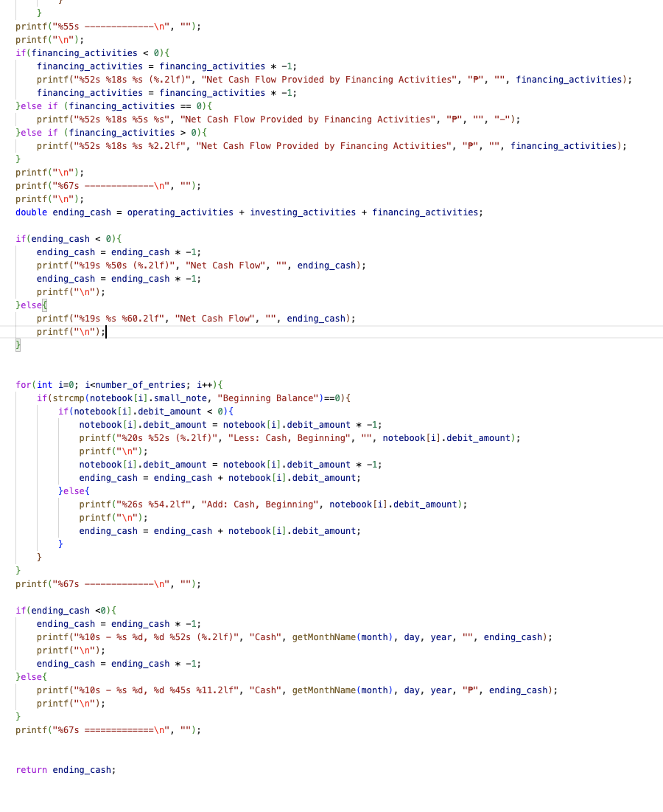
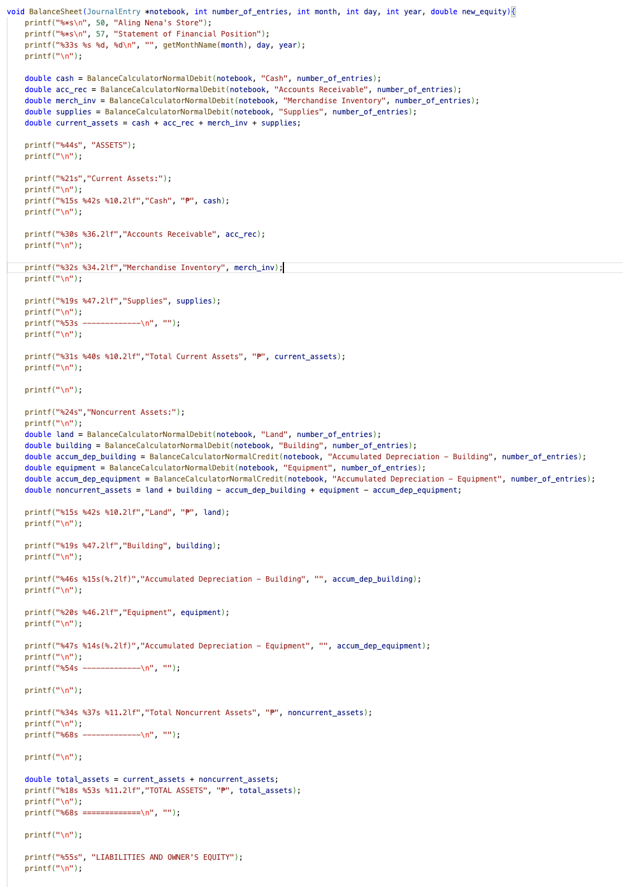
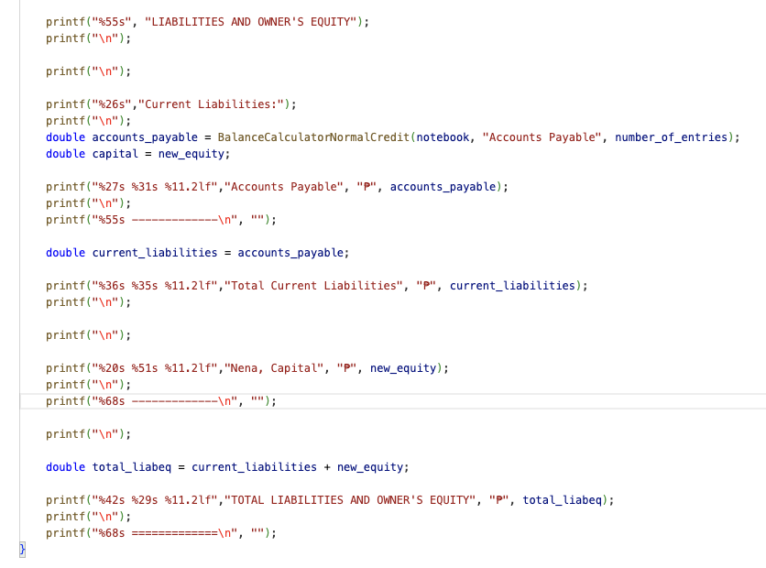
Balance Calculator
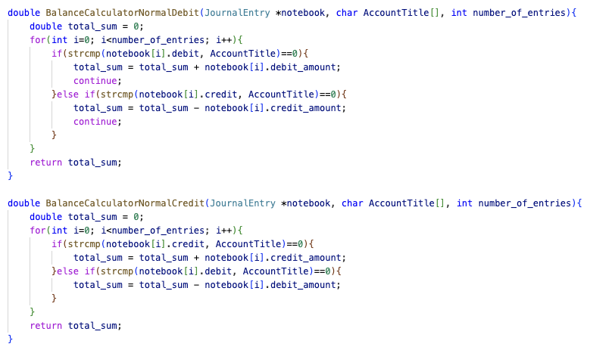
Unlike the ledger, this function allows the total calculation of an account title’s ending balances.

Limitations
- The current recording transaction function does not allow for multiple account titles in one transaction. Hence, the user is left inputting the respective accounts one by one.
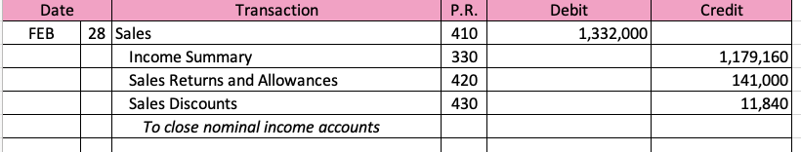
For example, most closing transactions look like this, but the user is forced to input their transactions like this instead:
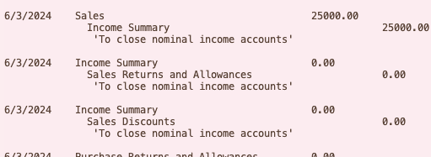
Although unproductive, the recording function still does its job at keeping the account titles balanced.
- The program is limited to pre-existing account titles, especially for checking the titles in iterations. New account titles have yet to be recognized, unless the developers opt to develop an enhanced version of the recording function.
- The program has inconsistent formatting, especially with long and short texts. Print-based outputs are limited on a “width” measurement to ensure equal distances across all formats, especially in the financial statements. However, unexpected but valid inputs may not cause the program to print the way it was programmed to print. Centering of variables and monetary descriptions may be off in some cases.

Code Snippets:
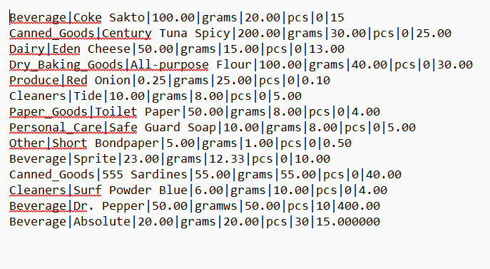
Initial Product.txt with initial products of the store
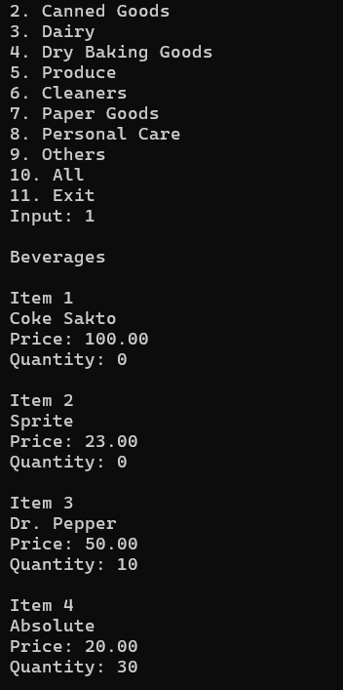
Sample Implementation of Display Product function

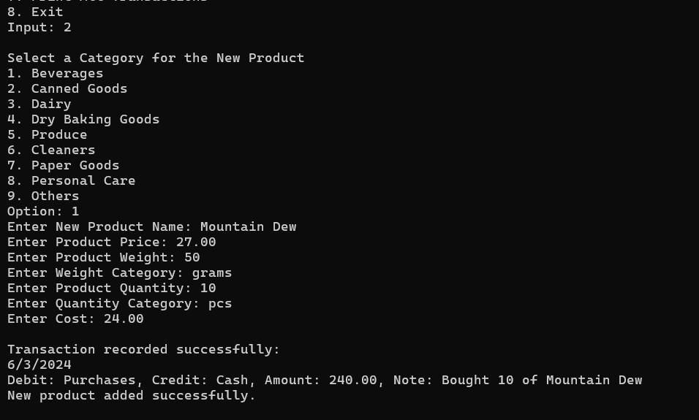
Sample Implementation of Add Function

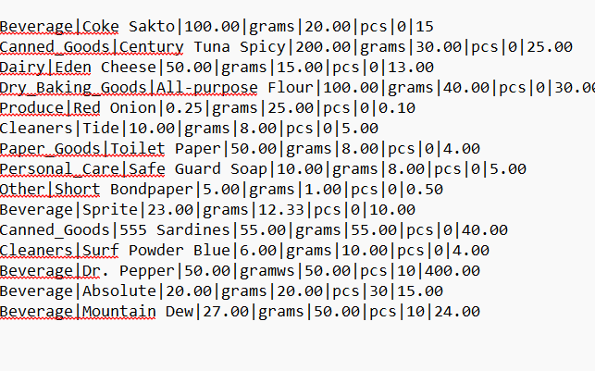
Updated Product.txt

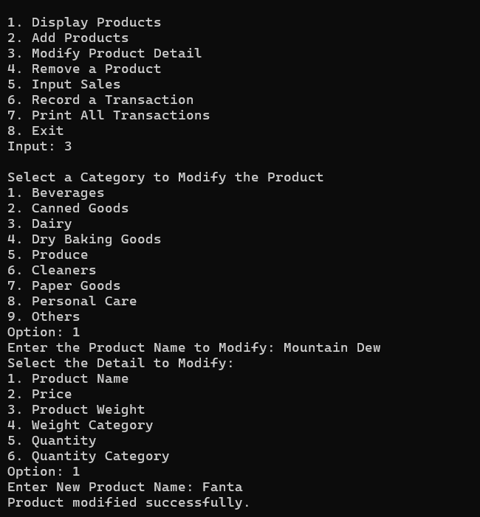
Sample Implementation of Modifier Function
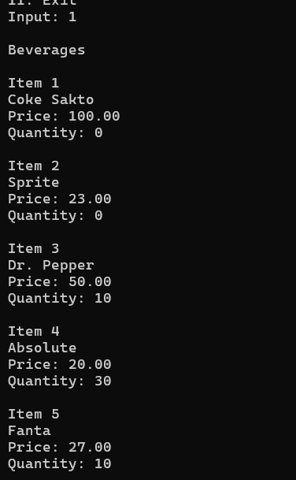
Item 5’s product name is modified
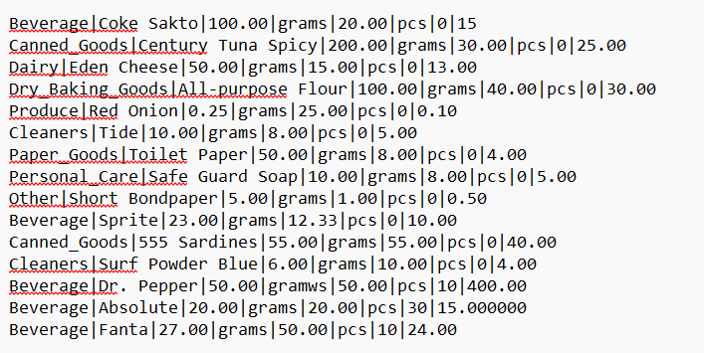
Updated Product.txt
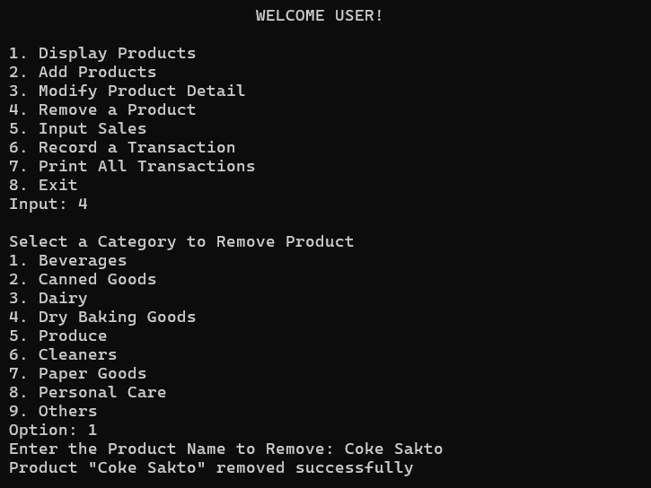
Sample Implementation of Remove Function
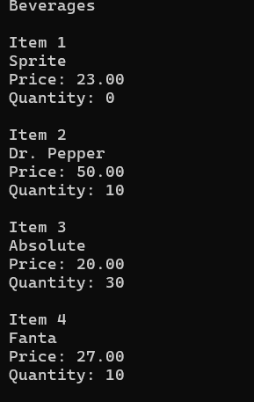
Beverage Catalog after removal of Coke Sakto
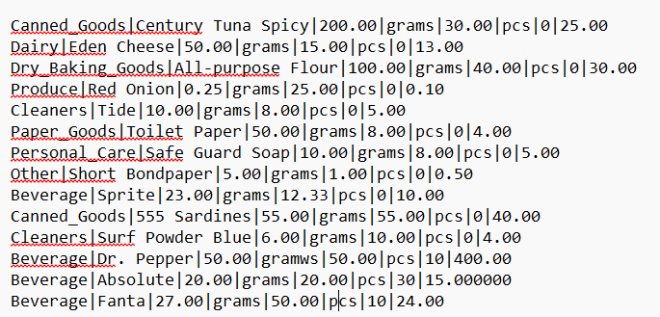
Updated Product.txt

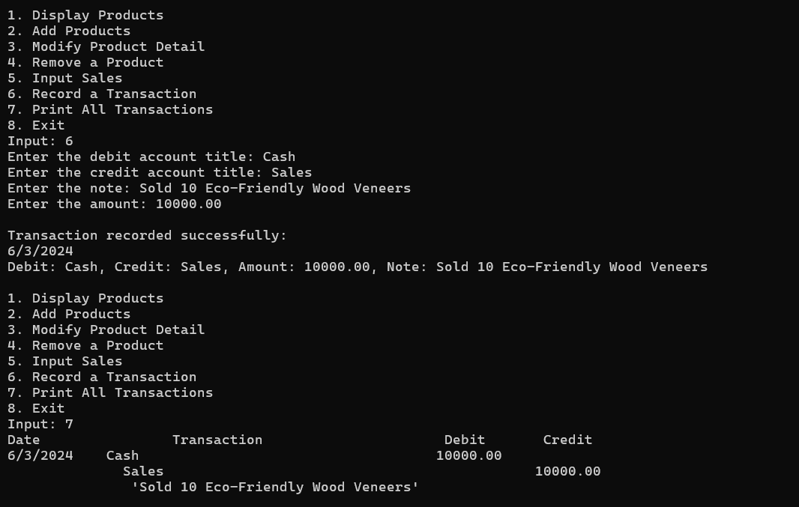
Sample Implementation of Transaction Function
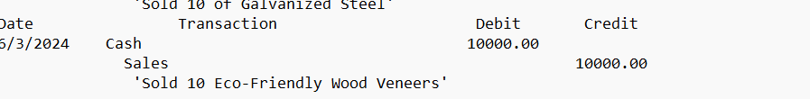
Transaction saved in transaction.txt

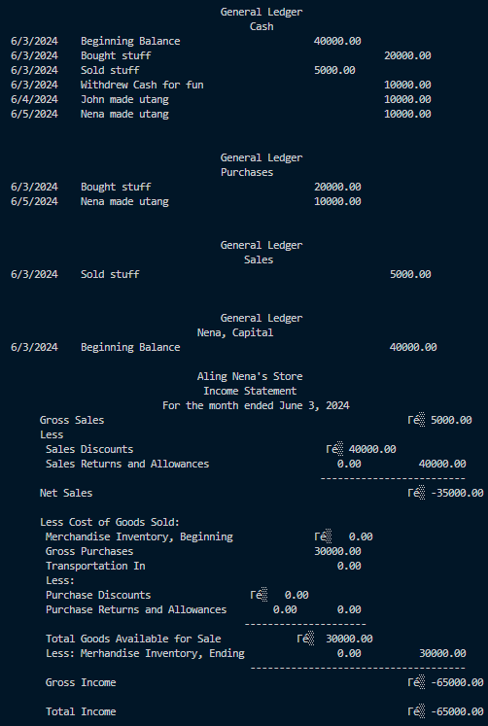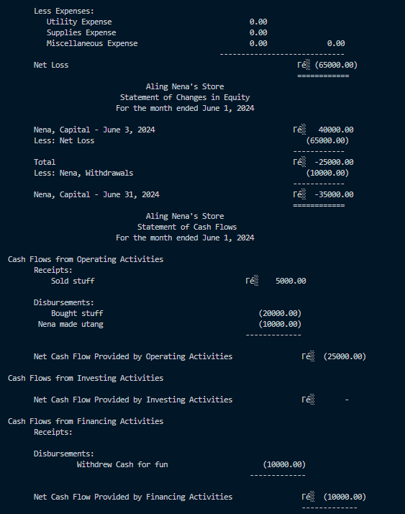
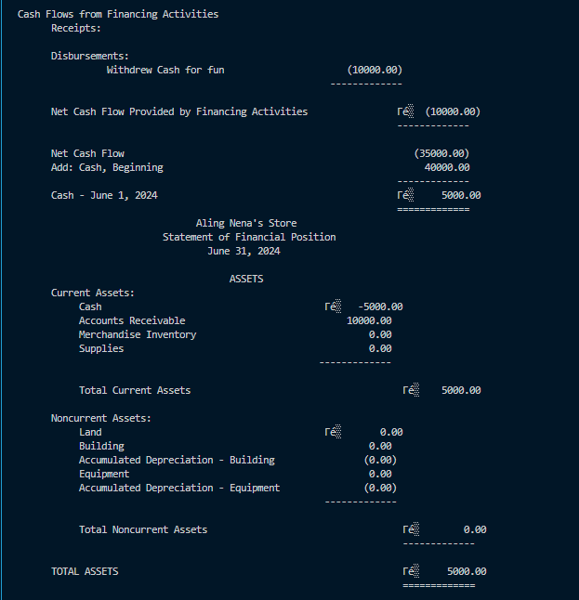
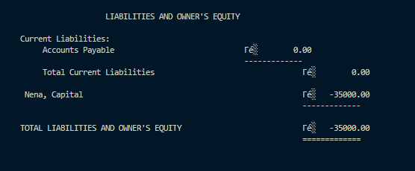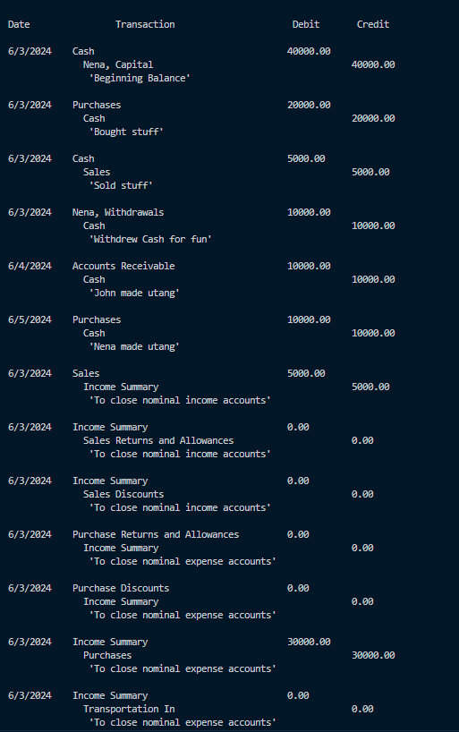
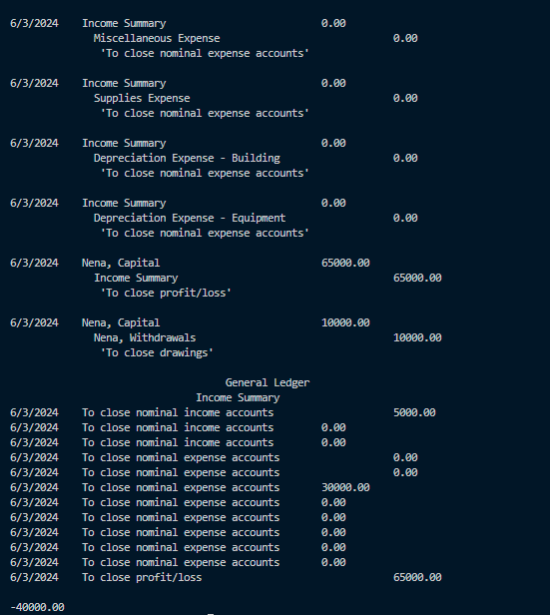
To be implemented accounting cycle function (Currently in a separate file)

Bibliography:
Alusen, Ma. L., & Javier, J. N. (2018). Accounting Practices of Sari-Sari Stores in Brgy. Makiling, Calamba, Laguna: Basis for Community Extension Program of the College of Business and Accountancy. PU-Laguna Journal of Multidisciplinary Research, 5. https://lpulaguna.edu.ph/wp-content/uploads/2019/01/1.-Accounting-Practices-of-Sari-Sari-Stores-in-Brgy.-Makiling-Calamba-Laguna-Basis-for-Community-Extension-Program-of-the-College-of-Business-and-Accountancy.pdf

